PARISH NEWS

FORSTER & NABIAC 29th December, 2019.

CHRISTMAS 1 – THE GOD WHO BRINGS HIS PEOPLE BACK

“Because Jesus himself was tested by what he suffered, he is able to help those who are being tested.” Hebrews 2:¹⁸

GAFCON
Rev James invited us to connect with The Global Fellowship of Confessing Anglicans (pn 08/12/19 www.gafcon.org) and I’d like to share Christmas Day’s prayer:
Almighty and invisible God, who dispersed the darkness of this world by the coming of your light, look, we pray, with serene countenance upon us, that we may acclaim with fitting praise the greatness of the Nativity of your Only Begotten Son. Who lives and reigns with you in the unity of the Holy Spirit, one God, for ever and ever. Amen

BEACH MISSION
Welcome to all participating members in the Beach Mission this year – a fantastic way of connecting with people as you inspire hope in the lives of those you meet with, telling them of Jesus! We pray for the team as they serve God, that doors will be opened for the message they share.

BUNNINGS BBQ
Our first date for 2020 is Saturday, 25th January. As this is part of the Australia Day long weekend it would be great to see if we have sufficient volunteers, otherwise we will need to cancel. List in the parish hall, please be thoughtful of this connection with the community.

OUR BOOKSHOP
Will re-open on Monday, 6th January, 2020.

VALE
Rev Trish Caddis has passed away. Rev Trish, although retired, filled in when clergy were away, or in between clery appointments, in our parish.
Suellen.

JANUARY LIGHT LUNCH
A great chance to “connect” during January, when so many groups take time off – Wednesday, January 8th, $8.00 each, 11.30 for noon in the Parish Hall. Perhaps a way to introduce friends or rellies to our church community.

CONNECT WITH US
FACEBOOK……………………Forster Anglican Church Community
PARISH WEBSITE…………..www.forsteranglican.com
CHURCH OFFICE…………….info@forsteranglican.com 5543 7683

DECEMBER MISSION FOCUS –THE CHRISTMAS BOWL

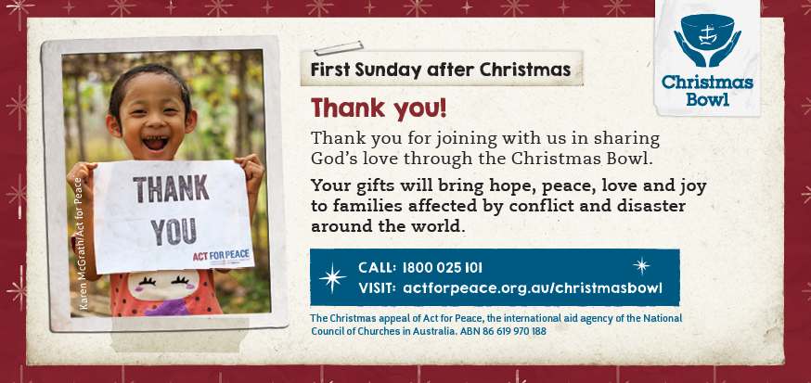

OUR LEADERSHIP TEAM
Senior Minister: Rev. Mark Harris 0425 265 547
Families Minister: Rev. James Brooks 0411 335 087
Priest in Local Mission:Rev.Helen Quinn 0427 592 723
PRAYERS FOR THE SICK AND RECOVERING
Ella E, Keith R, Lyn T, Marion & Peter R, Michelle, Rachael, Margaret B,
Zac L, Aileen G.

THE NEW YEAR – 2020!
At this time of the year we usually look back over the past twelve months
and wonder if we really achieved the list of things we set out to do in 2019! Let’s focus on some of the more important aspects of our life – reading the bible daily, praying more often, sharing the good news of Jesus with others, becoming LIFE LONG LEARNERS.

CAROLS BY CANDLELIGHT
Rev. James gave a very meaningful and thoughtful – and easy to understand – talk (assisted by Dan) to the 2,000 or so people at the Rotary Carols. It was great to connect with so many families from Toddler Time, and others that approached Rev James after the talk.

SAUSAGE SIZZLE AND ALL AGE CAROL SERVICE
Not only is Rev Mark our senior minister, he also barbecued the sausages and they were very tasty, plus salad. An amazing number of people came along. The carols were lead by Rev James, as Rev Mark was at Nabiac for their 7pm service. We enjoyed Maryvonne Campbell accompanying the singing on the piano, plus Joe Harris and Rev James leading the singing. A great group – about eighty – all ages – and some of the children were able to spend their time doing activities with Trish and helpers.

CHRISTMAS DAY
Once again, about eighty people enjoyed this service – with both Rev Mark and Rev James. It’s amazingly uplifting to see so many people participating in worshipping God, and being part of Jesus birthday!

DIRECT DEBIT GIVING
Such a fuss free way to ensure your offering is received WEEKLY
Acount Name: Anglican Parish of Forster/Tuncurry.
BSB: 705077 Account: 000400710
God loves cheerful givers!!
SAMARITANS
A big THANK YOU from the Samaritans for all our donations. These were used throughout the area for those in need – of which there are many. We’ll continue in January with out “Back to Basics” – holiday foods, items for the children when they start school for the first time, or when they go back after the holidays – brings back memories, doesn’t it?

PRAYER TO THE VULNERABLE GOD – Prayer no. 404 – 500 Prayers
Lord Jesus, we worship you, because you, majestic and everlasting, came to live among us and made yourself vulnerable.
From the safety of heaven You came to earth,
And you took on the humble flesh of a man. Not only that, but, though you didn’t deserve to die, You accepted the walk to the cross and died at the hands of men, shattered the power of death as you rose again, and now sit aain at the right hand of your Father, still involved on earth, still engaged, still making yourself vulnerable each day, as you offer yourself to us. What a Saviour you are. We bow before you.

A REFLECTION FROM ANGLICAN OVERSEAS AID
- How did you discover the joy of knowig Christ? Give thanks!
- Christianity is growing very rapidly in the developing world, but declining in Europe, North America and Australia. Why do you think this is the case?

COLOSSIANS 4:²⁻⁶
“Devote yourselves to prayer, being watchful and thankful. And pray for us, too, that God may open a door for our message, so that we may proclaim the mystery of Christ, for which I am in chains. Pray that I may proclaim it clearly, as I should. Be wise in the way you act towards outsiders, make the most of every opportunity. Let your conversation be always be full of grace, seasoned with salt, so that you may know how to answer everyone.”

Items for the Parish News for January, 2020 to Trisha Harris by 12 noon Wednesday, thanks. Email trishaharris10@gmail.com .

