PARISH NEWS
PENTECOST 10 – STRENGTHENED WITH GOD’S SPIRIT
29th JULY, 2018.

“I am the living bread that came down from heaven,” says the Lord. “Whoever eats of this bread will live forever; and the bread that I will give for the life of the world is my flesh.”
John 6:⁵¹

OUR PARISH VISION –
“We will connect meaningfully with our community in order to inspire hope and transformed lives through faith in Jesus.”

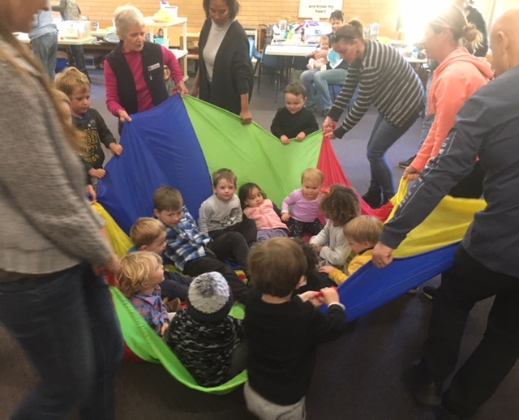

TODDLER TIME MONDAY, 23rd JULY –
What an amazing first day back at Toddler Time after the school holidays. Gorgeous toddlers – and so hard to count for morning tea! Maybe 19 or 21 – lost count – and you can see from the background we managed with our “corner kitchen”.

NEXT SUNDAY, THE 5th AUGUST, WILL BE OUR 5th SUNDAY – MEANING ONE COMBINED PARISH SERVICE AT ST. ALBAN’S AT 9.30am - AS WE WELCOME ASSISTANT BISHOP CHARLIE MURRY INTO OUR PARISH.
If parishioners from branch churches could bring along a small plate of morning tea to share (as you always do) that would be a great help.
Following morning tea on the 5th, we will be treated to a sausage sizzle – offering us the opportunity of spending further time together. The sizzle will replace our monthly BBQ.

BISHOP PETER invites all Anglicans to pray that God will guide us with wisdom and insight we need by regularly praying this prayer: -

Come Holy Spirit of God,
restore the lives which, without you, are lifeless and dead;
kindle the hearts, which without you, are cold and dull;
enlighten the minds which, without you, are dark and blind;
fill the church which, without you, is an empty room;
teach us how to praise and pray
that we may grow together in love
and have courage to make wise decisions
as servants, messengers and ambassadors of God’s reign,
all this we ask in the name of Jesus Christ, our Lord. Amen.

SAMARITANS DONATIONS OF FOOD FOR JULY –
BREAKFAST FOODS – cereals, tinned fruit, orange juice, long life milk, pancake mix – all sorts of food that can be used for breakfast. As usual great support.

OUR MISSION FOCUS FOR JULY –
The Samaritans Winter Appeal. During the winter months of the year there are people who need winter warmth – let’s spare a thought and give cash donations generously – mission boxes in all churches.

DISCUSSING DEMENTIA –
The Uniting Church of Forster-Tuncurry are holding an informative seminar on dementia, focusing on “Caring” …. caring for those living with dementia and the carers. Presented by Rev. Frank Van Der Korput on next Saturday, 4th August, 9.30am -12 noon. Cost $10 – (incl. morning tea and notes) To-morrow is the LAST DAY to book. Pastor Geoff Battle 6555 8573 or Jenny Pulling 0425 365889

PARISH FETE -
Saturday, 20th October. We will be holding a “Fete Meeting” on Tuesday, 7th August, at 2pm in the parish hall to consolidate our plans. Check out the list of stalls and add your name – now!
Preparation time – especially for planting, and craft items and looking up Christmas cake and pudding recipes, whatever your field of endeavor is now is the time to begin the process.

MEN’S DINNER –
Tuesday, 7th August, 6.00pm for 6.30pm. Cost $15.00 each, plus drinks. The guest speaker for this occasion if Pastor Geoff Battle from the Uniting Church, Forster. Lists at all churches or phone the parish office.

A SNIPPET OR TWO FROM REV’D MARK’S MESSAGE LAST SUNDAY
(Ephesians 2:11-22) -
One of the key markers of church should be the absence of hostility towards other members of the church. Too often ‘we’ in the church don’t treat each other as equal members of the body of Christ because we often focus more on what we disagree with, than what we agree with.
We need to LIVE the peace we’ve received not just talk about it!
We need to remember what it was like to be unsaved and what it’s like to be saved, so we can be motivated to share the PEACE we’ve found in Christ with our families and friends who don’t know God – so they too can have HOPE.

CULTURE AND CHRIST GROUP- The Culture and Christ group resumed a few weeks ago at St. Nicholas’ starting around 10 am each Monday. All are welcome, be it to paint, create, eat, drink tea or just to chat. If you have other creative talents such as knitting, sewing or writing please come along. We would love to have someone come and play the piano for us occasionally!

MINI LUNCH – After missing the July lunch let’s make sure we remind all our friends and neighbors that the August mini lunch will definitely be on. The date – Wednesday, 8th August, 11.30am for 12 noon start. $7.00 each. The new kitchen will be ready for the occasion.

ST. ALBAN’S KITCHEN –
And, yes, there will be a new stove/oven – great news to many of the people who work in the kitchen. Impressive donations coming in - $1,900.00 so far, $1,000.00 to go. New fridge/freezer has been donated. Installation of all other gear happening on Thursday, 2nd August.
Thanks to all parishioners who have endured the process.

MEMBERS OF OUR CHURCH COMMUNITY WITH ONGOING NEEDS –
Hugo Walmsley, Elaine Latta, Alan Winston, Nina Learmond, Rosalyn Ferris, Ella Engel, Jenny Lawson, Maureen Armstrong, George Hodgson, Louise, Peter Board, Dianne Hardin, Wayne Thompson.
If you would like to add someone to the Parish Prayer list, be sure to obtain permission from the person concerned and then contact the Parish Office.
We commend to God’s keeping those who have recently died – Leonie Bell from our Nabiac congregation and we pray for those who mourn her passing.
We remember with thanks those we have loved whose anniversary occurs at this time – William Belton, Harry Avery, Alan Roche, Reay Sawyer.

PARISH BOOKSHOP –Stock changeover date coming up on Friday, 3rd August. If you need a special purchase from Koorong, Port Macquarie, contact Deborah 0402 359780 or Phillip 0422 036656 asap.

OP SHOP – BOOKS are now in short supply, if you can help that would be appreciated. And shortly we will all need to go through last year’s spring gear and the Op Shop is always delighted to accept your donations.

CONTACT DETAILS
Senior Minister/Rector: Rev’d Mark Harris 0425 265 547
revmarkharris@icloud.com
Priest in Local Mission: Rev Helen Quinn 0427 592 723
Parish Office: St. Alban’s Anglican Church: 5543 7683
info@forsteranglican.com
Parish Secretary: Judy Hall 0400 890 728
Op Shop: Head St Car park 6555 4267
Book Shop: bookshop@forsteranglican.com 5543 7683
Parish Website: www.forsteranglican.com
Items for Parish News: Phone Lyn Davies 0491 136455 or email: clivelyn46@gmail.com or Parish Office 5543 7683 by noon Wed, or text, thanks.
Our bank details: BSB 705077 Account 000400710
Account name: Anglican Parish of Forster/Tuncurry

