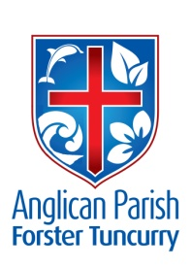
PENTECOST 3 – IS GOD DEAD?
30TH JUNE, 2019.

Those who find their life will lose it, and those who lose their life for Jesus’ sake will find it. Matthew 10.³⁹

Our Parish Vision:
CONNECTING MEANINGFULLY.
INSPIRING HOPE.
TRANSFORMING LIVES.
THROUGH FAITH IN JESUS.

THE DECONSECRATION OF ST. JOHN’S, DYERS CROSSING.
We welcome Bishop Charlie Murry to our parish today. Bishop Charlie will be at Dyer’s Crossing Service of Thanksgiving at 10am.
PRAYER
SICK AND RECOVERING
Ella Engel, Jenny Lawson, Keith Roach, Nadia Maybury, Lyn Thompson, Marion & Peter Roberts, Margaret Burrows, Laurie Medcalf, the Pearson family, Peg Sawyer.

OUR MISSION FOCUS FOR JULY IS THE ANGLICAN BOARD OF MISSION-AUSTRALIA LTD.
ABM’s vision: We want to see people everywhere experience the wholeness of life God offers in Jesus Christ, and support our partners as they participate in God’s mission.

SAMARITANS DONATIONS
During July we’re encouraged to give breakfast foods – that opens up all sort of possibilities. It’s always heart-warming to see the different foods collected during the month, always your choice.

BUNNINGS BBQ FOR TODDLER TIME
Saturday, 13th July – calling for volunteers to assist for two hour shifts. Check out the notice board and see where you can help out. New volunteers encouraged to join in this community event.
We have also received further dates for this year – Saturday, 17th August and Saturday 7th December

MY COMMUNITY PROJECT
The parish’s two submissions for funding of St. Paul’s renovations and St. Alban’s improvements have been accepted and now join other projects for voting by the public. Those projects with the most community support will receive funding .
We can individually show our support by either going online to https://mycommunityproject.service.nsw.gov.au or visiting Service NSW in Tuncurry and voting for our two projects. You will need to show your medicare card before you vote.
Voting closes on Monday, 15th July.
Talk to Clive Davies if you need more info.
PARISH NEWS FOR THE MONTH OF JULY
Janet Lawrence will be the editor. All info direct to Janet 6554 5981, 0448 502 684, jan2max@bigpond.net.au, by noon each Wednesday. Thanks for all the help and encouragement I have been given during June, Lyn.

PASTORAL PARTNERS
Heather Webster has called a meeting for Monday, 1st July, at St. Alban’s Hall, 3pm-4pm. We would hope that as many people as possible join in and discuss how your connections are going.

From Rev. Helen –
Naidoc Week , we celebrate with our first peoples this historic week with history, culture and achievements of Aboriginal and Torres Strait Islander peoples.
NAIDOC is celebrated not only in indigenous communities, but by Australians from all walks of life.
The week is a great opportunity to participate in a range of activities and to support your local Aboriginal and Torres Strait Islander community.
We are one community but we are many members. Let us walk together with mutual respect and harmony to make this town strong!
Posters in both churches with ideas of how YOU can participate.
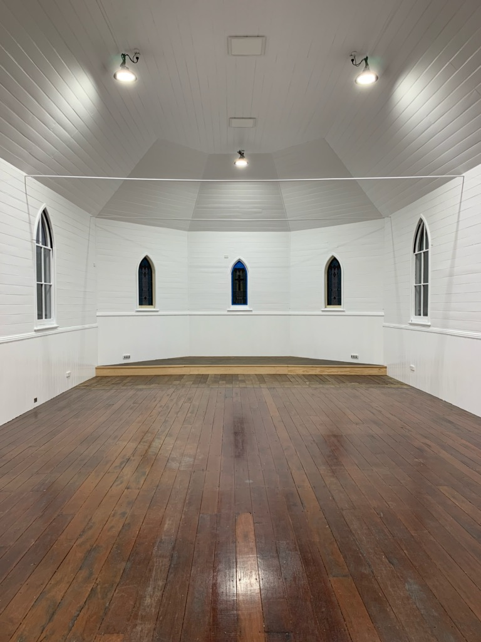

ST. PAUL’S, NABIAC
As from next Sunday, 7th July, services will be held every Sunday, the first and third will be All Age, and the second and fourth will be Traditional, all services will be at 10am.

Senior Minister: Mark Harris
T: 0425 265 547. Parish Email:info@forsteranglican.com.
Fb:Forster Anglican Church Community.

