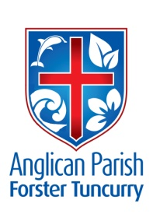
PENTECOST 19 – FELLOWSHIP
30TH SEPTEMBER, 2018.

Salt is good; but if salt has lost its saltiness, how can it be seasoned? Have salt in yourselves, and be at peace with one another. Mark 9:⁵⁰

OUR PARISH VISION:
“We will connect meaningfully with our community in order to inspire hope
and transformed lives through faith in Jesus.”

OUR PARISH FETE. 3 WEEKS TO GO!
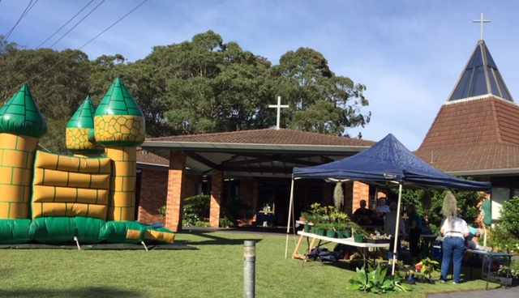

Our “Follow-up” meeting for the fete is being held THIS Tuesday, 2nd October, at 3pm in the parish hall.
Donations of saleable goods can be delivered to the parish hall from the week beginning Monday, 8th October. The back of the parish hall is the site for these items, as Toddler Time will also be using the hall for their get together on Monday, 15th October.
Beautifully designed pamphlets are available for you to give to your friends, neighbours, rellies, everyone in your street.
There is a map of Forster/Tuncurry PLEASE carefully mark where you will be making deliveries. Thank you.

MEN’S DINNER. THIS TUESDAY, 2nd October, 6pm for 6.30pm. Cost $15.00 each plus drinks. Our guest speaker will be Rev’d. Les Forester, speaking about his trip to Israel with accompanying overheads. Lists at all churches or phone the parish office or Clive 0412 653 061.

AS WE WORSHIP OUR GOD WE INCLUDE IN OUR PRAYERS THIS WEEK:
Bishop Peter’s prayer
Our prayer for a Families Minister
Bishop Peter & Nicki
Asst. Bishop Charlie Murry & Melissa
Asst. Bishop Sonia Roulston
Parish Leaders
Liz Burns
The First People of the Diocese

JAMES 1:²²
Do not merely listen to the word, and so deceive yourselves. Do what it says.

MEMBERS OF OUR CHURCH COMMUNITY WITH ONGOING NEEDS
Hugo Walmsley, Alan Winston, Ella Engel, Jenny Lawson, Maureen Armstrong, George Hodgson, Louise, Keith Roach, Paul McIntosh, Michelle, Max Kennedy,

If you would like to add someone to the Parish Prayer list, be sure to obtain permission from the person concerned and then contact the Parish Office.

OUR MISSION FOCUS FOR OCTOBER IS LIZ BURNS, Church Missionary Society serving the Lord in Dodoma, Tanzania.
“I live by faith in the Son of God who loved me and gave himself up for me.” Galatians 2:²⁰

UPCOMING EVENTS:
Tuesday, 2nd October – Follow-up Fete meeting, 3pm
Men’s Dinner, 6pm for 6.30pm
Wednesday, 3rd October – Service at Estia, Forster, 10.30am
Friendship Group, St. Nicholas, 10am.
Saturday, 6th October – Bunnings BBQ
Sunday, 7th October – Daylight Saving commences
Tuesday, 9th October – Parish Council, 4pm
Wednesday, 10th October – Mini Lunch, 11.30am for noon
Saturday, 13th October – 8am-11.30am Working Bee at St. Alban’s
Saturday, 20th October – Parish Fete at St. Alban’s
PEWS AND SCONCES. All the pews have been sold. There are five sconces @ $100.00each and two sconces @ $150.00each. These items can be viewed at St. Alban’s this morning. Speak to Clive.

COURTHOUSE CUPPA MINISTRY
Owing to changes at the Forster Courthouse the Courthouse cuppa ministry has now ceased. On behalf of the Parish I would like to thank all those who have been involved in this ministry over the past 30+ years. Suellen.
The Parish in return, thank Suellen for her involvement in this ministry.

BUNNINGS BBQ SATURDAY, 6th OCTOBER proceeds to Toddler Time. The next BBQ date that we have been offered is Saturday, 6th October. List for volunteers is on the board at St. Alban’s or phone Clive 0412 653 061.
Bunnings have advised us of two further BBQ dates for Toddler Time, Saturday, 17th November and Saturday, 19th January.

SIX STEPS TO LOVING YOUR CHURCH. From the Ministry of the Few to the Ministry of the Pew.
The assignment for the first Sunday: don’t sit in your ‘normal’ seat (if you have one). Pray about where to sit, and sit next to someone different.
The assignment for the second Sunday: After the service to look for a way to practically serve another person. Have a conversation with someone after church. Ask them how their week has been, and ask what you could pray for them.
The assignment for the third Sunday: Choose at least one new thing you could do during church to encourage and help others, and put it into practice.

PARISH BOOKSHOP
There will be a week’s sale of 10% off all stock commencing on the day of the Parish Fete, Saturday, 20th October thru to Friday 26th October.

CAPPUCINO DRINKERS
A further $112. Has been forwarded to the Chaplaincy, thanks to Keith B. and Rosa.

THOUGHTS ON SAMARITAN DONATIONS FOR OCTOBER AND NOVEMBER
During the next two months we are asking for CHRISTMAS FARE, from food to gifts for the whole family.

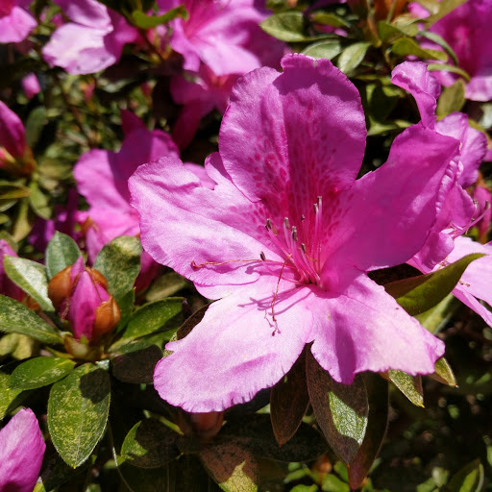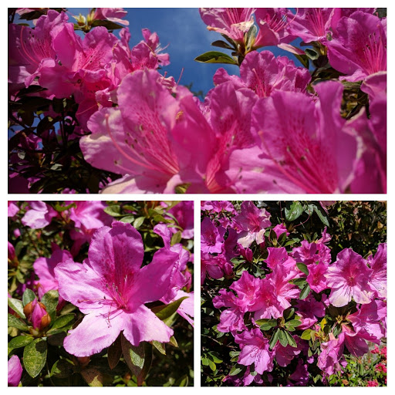
The garden at St. Alban’s is stunning, thanks to the Tuesday Gardening Group.
Talk to Viv and Joan May.

BODY BUILDING HINTS FOR THE BODY OF CHRISIT # 2. Ephesians 4²⁹
“Do not let any unwholesome talk come out of your mouths, but only what is helpful for building others up according to their needs, that it may benefit those who listen.”
An important way to build up the body of Christ is to use our words to encourage and support each other. Complaining and criticism can destroy a church like poison but words of encouragement build up the Church and honour Christ.

Remember to change your clocks, watches etc as DAYLIGHT SAVING begins at 2am next Sunday, 7th October.

Senior Minister/Rector: Rev’d Mark Harris 0425 265 547
revmarkharris@icloud.com
Priest in Local Mission: Rev Helen Quinn 0427 592 723
Parish Office: St. Alban’s Anglican Church: 5543 7683
info@forsteranglican.com
Parish Secretary: Judy Hall 0400 890 728
Op Shop: Head St Car park 6555 4267
Book Shop: bookshop@forsteranglican.com 5543 7683
Parish Website: www.forsteranglican.com
Fb: Anglican Parish of Forster-Tuncurry.
Items for Parish News: Phone Lyn Davies 0491 136 455 or text, email clivelyn46@gmail.com, or Parish Office 5543 7683 by noon Wed, thanks.
Our bank details: BSB 705077 Account 000400710
Account name: Anglican Parish of Forster/Tuncurry

