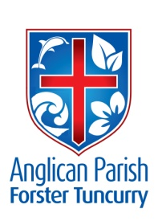
CHRISTMAS 1 - WHAT COMES FROM THE HEART
30th DECEMBER, 2018.

Clothe yourselves with love, which binds everything together in perfect harmony. And let the peace of Christ rule in your hearts, and be thankful. Col. 3:¹⁴⁻¹⁵

WE WELCOME BISHOP SONIA ROULSTON TO OUR PARISH THIS MORNING AS WE MEET TOGETHER AS GOD’S FAMILY.

OUR MISSION FOCUS FOR DECEMBER IS THE CHRISTMAS BOWL.
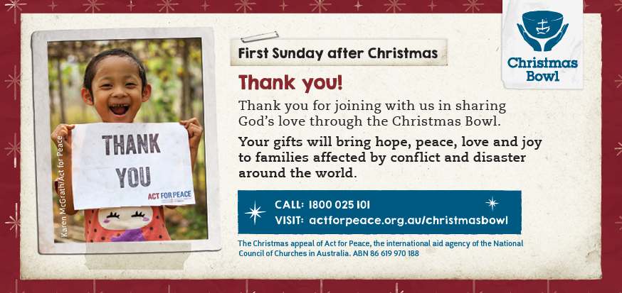

Thank you for being part of the Christmas Bowl.
In a world so full of disaster, conflict, injustice and pain, you’ve joined with Christian Communities across Australia to make a powerful difference for people in need.

SERVICE TIMES FOR 2019
As of next Sunday 6th January, 2019 service times will change. They will be as follows:
- St. Alban’s 8.30am, 10am and 5.30pm
- St. Paul’s & St. John’s 10am
MEMBERS OF OUR CHURCH COMMUNITY AND FRIENDS WITH ONGOING NEEDS
Ella Engel, Jenny Lawson, Maureen Armstrong, George Hodgson, Louise, Keith Roach, Michelle, Max Kennedy, Beryl Allen, Nadia Maybury, Sue Hollis, Lyn Thompson, Marion & Peter Roberts, Allan Peel, Isabel McBride, Russell Parry.
We commend to God’s keeping those who have recently died, and we pray for those who mourn their passing.
We remember with thanks those whom we have loved whose anniversary occurs at this time – Philip Frank Ovens, Alex Campbell.

OUR PARISH VISION:
We will connect meaningfully with our community in order to inspire hope and transformed lives through faith in Jesus.

BUNNINGS BBQ
Our first date for 2019 is Saturday, 19th January. Phone Clive Davies 0412653061 if you can help out, it’s a great way to outreach to our community.

BOOKSHOP NEWS from Phillip Castle
Bookshop will reopen Monday 7th January.
Thankyou for your custom this year.

SAMARITANS DONATIONS
Thoughts for January – holiday food – popcorn, chips, biscuits, jelly, topping, tins of fruit, long life custard, or what is YOUR favourite holiday food? Also, we need to think about children’s lunches as they start the school year, especially the “first timers”.

HE SHALL REIGN FOREVERMORE a great song of worship, first verse:
In the bleak midwinter all creation groans
And for a world in darkness frozen like a stone
Light is breaking in a stable for a throne
And He shall reign forever more, forevermore.
A PRAYER AS WE WELCOME IN 2019
Lord,
We welcome you as the Light of the World,
As you light our lives, help us show your light in practical and life-giving ways,
At home and abroad, light a path for us
That we may be beacons of your everlasting love for us. Amen.

LIGHT LUNCH 2019
A change of name!! You are invited to come along and enjoy a “light lunch” on Wednesday, 9th January at St. Alban’s Hall. The cost is $8.00 and you will be offered a two course lunch followed by tea and/or coffee. Usual time, 11.30am for 12 noon. Great conversations, catch-ups and laughter.
A good time to mark your calendars – every second Wednesday of each month!

SUMMERLIFE
Thirtyfive members of “Summerlife” Scripture Union are staying at St. Alban’s this week.

READINGS 6TH JANUARY – THE EPIPHANY OF OUR LORD
Isaiah 60:1-6, Psalm 72:1-7,10-14, Ephesians 3:1-12, Matthew 2:1-12.
13th JANUARY -THE BAPTISM OF OUR LORD
Isaiah 43:1-7, Psalm 29, Acts 8:14-17, Luke 3:15-22.

Senior Minister/Rector: Rev’d Mark Harris 0425 265 547
revmarkharris@icloud.com
Priest in Local Mission: Rev Helen Quinn 0427 592 723
Parish Office: St. Alban’s Anglican Church: 5543 7683
info@forsteranglican.com
Parish Secretary: Judy Hall 0400 890 728
Op Shop: Head St Car park 6555 4267
Book Shop: bookshop@forsteranglican.com 5543 7683
Parish Website: www.forsteranglican.com
Fb: Anglican Parish of Forster-Tuncurry.
Items for Parish News: Lyn Davies 0491 136 455. Parish Office 5543 7683 by noon Wed, Thanks.
Our bank details: BSB 705077 Account 000400710
Account name: Anglican Parish of Forster/Tuncurry
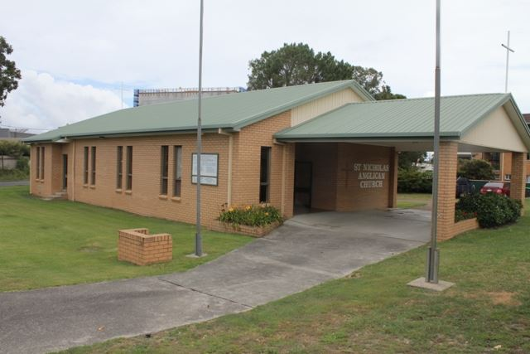
A SHORT HISTORY OF ST. NICHOLAS’ CHURCH, TUNCURRY
When St. Nicholas was built in 1960 it was built as a Church Hall. A church was to be erected sometime in the future. This was never done.
As a Church Hall the building was designed to have a sanctuary down one end which could be shut off with folding doors. When the building was needed for worship the sanctuary area would be opened up. The furniture in the body of the hall arranged appropriately for worship services. After worship the sanctuary would be closed up…the furniture in the body of the hall moved around…so we had a hall area for a range of church activities.
After a number of years St. Nicholas building was set up permanently as a church…only very occasionally being used as a hall. Indeed, the folding doors between the sanctuary and the body of the building were removed.
In 1995 a major project to modernize St. Nicholas, Tuncurry took place. A new pitch roof, a drive-thru carport area, the verandah area was filled in and the wall/doors between the verandah and the body of the church were removed to provide greater seating capacity, a larger sanctuary area, all new windows, the exterior of the building was brick veneered, and a paved driveway was constructed.
Finally, to complete the refurbishment of St. Nicholas four stained glass windows…depicting the four evangelists Matthew, Mark, Luke and John were designed and installed.
And now to-day we are here as another day of history is being made.

