Forster-Tuncurry Anglican Parish

Summer Program, 2018

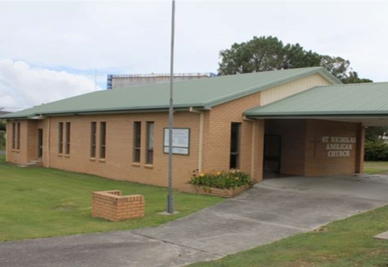
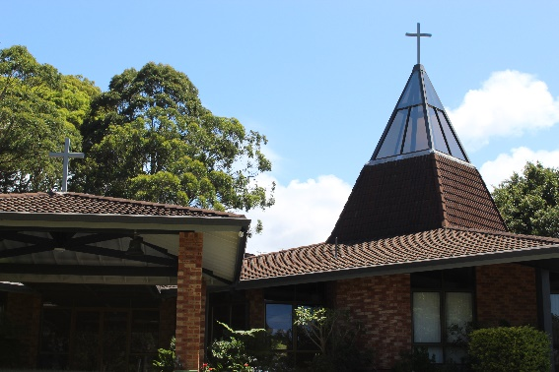

One Parish – Four Centres

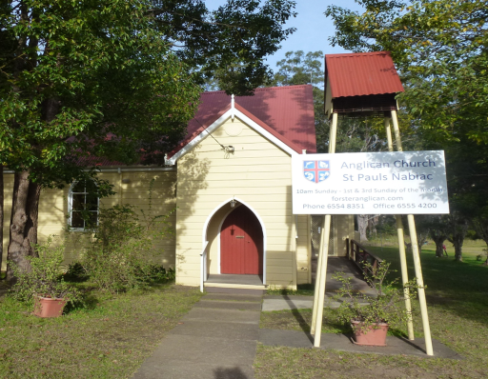
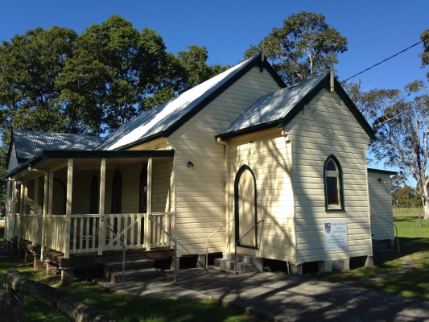

“We will connect meaningfully with our community in order to inspire hope and transformed lives through faith in Jesus.”

6 St Alban’s Place Phone: (02) 5543 7683
FORSTER 2428 www.forsteranglican.com
Office hours - Mon – Fri e-mail: info@forsteranglican.com
9.00 am – 12 noon fb: Anglican Parish of Forster-Tuncurry

Printed Wednesday, 17 January 2018
TERM PROGRAM
Traditional Services
Date | OT/reading | Epistle/reading | Gospel/reading
7th January | Gen 1.1-5 | Acts 19.1-7 | Mark 1.4-11
14th January | Jonah 1 | 1 Cor 6.12-20 | John 1.43-51
21st January | Jonah 2 | 1 Cor 7.29-31 | Mark 1.14-20
28th January | Jonah 3 | 1 Cor 8.1-13 | Mark 1.21-28
4th February | Jonah 4 | 1 Cor 9.16-23 | Mark 1.29-39
11th February ^{Transfiguration} | 2 Kings 2.1-12 | 2 Cor 4.3-12 | Mark 9.2-9
18th February ^{Lent 1} | Gen 9.8-17 | 1 Peter 3.18-22 | Mark 1.9-15
25th February ^{Lent 2} | Gen 17.1-7 | Rom 4.13-24 | Mark 8.22-38
4th March ^{Lent 3} | Ex 20.1-17 | 1 Cor 1.18-25 | John 2.13-22
11th March ^{Lent 4} | Num 21.4-9 | Eph 2.1-10 | John 3.14-21
18th March ^{Lent 5 AGM} | Jer 31.31-34 | Heb 5.5-14 | John 12.20--33
25th March ^{Palm Sunday} | Ex 13.1-3, 7-9 | Gal 3.10-14 | Mark 11.1-11
30th March ^{Good Friday} | Isa 52.13-53.12 | Heb 10.16-25 | Jn 18.1-19.42
1st April ^{Easter Day} | Isa 25.6-9 | 1 Cor 15.1-11 | Mark 16.1-8
8th April | Acts 4.32-37 | 1 John 1.1-10 | Jn 20.19-31
15th April | Acts 3.12-20 | 1 John 2.1-11 | Lk 24.36b-48
22nd April | Acts 4.5-12 | 1 John 2.12-29 | Jn 10.11-18
29th April ^{Combined Forster} | Acts 8.26-40 | 1 John 3.1-11 | Jn 15.1-8
Contemporary
Date | Focus passage | Topic
7th January | Mark 1.4-11 | Jesus’ Baptism
14th January | Jonah 1 | Rebellious prophet
21st January | Jonah 2 | Jonah’s prayer
28th January | Jonah 3 | Patient God
4th February | Jonah 4 | Merciful God
11th February ^{Transfiguration} | Mark 9.2-9 | Jesus’ Transfiguration
18th February ^{Lent 1} | Mark 1.9-15 | Jesus’ temptation
25th February ^{Lent 2} | Mark 8.22-38 | Who do you say I am?
4th March ^{Lent 3} | John 2.13-22 | Jesus’ Zeal
11th March ^{Lent 4} | John 3.14-21 | God’s plan to save
18th March ^{Lent 5 AGM} | John 12.20--33 | Jesus to be Glorified
25th March ^{Palm Sunday} | Mark 11.1-11 | Palm Sunday
30th March ^{Good Friday} | Jn 18.1-19.42 | The Passion
1st April ^{Easter Day} | Mark 16.1-8 | Empty tomb!
8th April | 1 John 1.1-10 | Walk in the light
15th April | 1 John 2.1-11 | Cleansed from all sin
22nd April | 1 John 2.12-29 | Abide in Jesus!
29th April ^{Combined Forster} | 1 John 3.1-11 | Children of God!

GROWTH GROUPS - During School term

K.Y.B. KRAMBACH 1st & 3rd Mondays - 1.30pm Contact Peg Sawyer
Doug Dowling Tuesdays - 5.00pm. Contact Doug Dowling
St Paul’s NABIAC Alt. Tuesday - 6.00-7.00pm. Contact Geraldine Carson
St Nix Thursdays - 10.30am. Contact Rev Bill
St Alban’s Thursdays -2.00-3.00pm. Contact Heather Dwyer
Clive and Lyn Fridays - 1.00-3.00pm. Contact Clive Davies

KIDS CONNECT - During School term

Toddler Time (0-5yrs + Parents/carers) Mondays - 9.30am St Alban’s Church Hall
Contact Trisha Harris
Special Religious Education (SRE), Fridays Forster & Tuncurry, 9.30am - 11.30am
Contact Rev Mark
SRE, Fridays Krambach, 9.30am & 10.00am Contact Dennis Ang
Scripture in Forster /Tuncurry (SIFT) Committee Chairperson Dennis Ang

FOCUS ON PRAYER - During School term

Wednesday 8.45am St. Alban’s after Tea, toast & Theology
Prayer Chain Contact the Parish office

FOCUS EVENTS

Working Bee - Parish Hall – Sat 10th March
Men’s Dinner - 1st Tuesday bi-monthly from Feb 6pm - St Alban’s Hall
Games afternoon - 2nd Saturday 1pm - St Nicholas

VITAL GROUPS

Book-Shop – Monday to Wednesday & Friday 9am - 12pm
Op-Shop – Monday to Friday 9am - 4pm; Saturday 9am to 12.30pm
Culture and Christ – every Monday 10am at St Nicholas from 22nd January
Walking Group – St Alban’s carpark each 1st & 3rd Monday 9.30am
Gardening Group – St Alban’s Tuesday mornings 9am
Rugrats – Tuesday - 10.00 am St Alban’s Hall
Parish Council - 2nd Tuesday of each month - 4.00 pm St Alban’s Hall
Tea, Toast & Theology - every Wednesday - 8 - 8:45am St Alban’s Hall
Court-care – Wednesday Twice monthly – Contact Suellen Belton for more info
Friendship Group - 1st Wednesday of each month at St Nicholas 10am
Mini-Lunch - 2nd Wednesday of each month - 11.30 am St Alban’s Hall
Pastoral Partners - Contact the Office for more info

ST. ALBANS SERVICES
Saturdays: 5.30 pm Contemporary + Communion (Not January)
Sundays: 8.00 am Holy Communion **
9.30 am Contemporary (Communion on the last Sunday) **
OTHER CENTRES
Tuncurry, St. Nicholas’ 9.30pm Every Sunday – Holy Communion **
9.30pm Every Thursday – Holy Communion
Nabiac, St. Paul’s 11.30am Contemporary – 1st Sunday
11.30am Holy Communion – 3rd Sunday
Dyers Crossing 11.30am Contemporary – 2nd Sunday
11.30am Holy Communion – 4th Sunday

**The parish combines (5th Sunday) at St Alban’s on 29th April - 9.30am

RETIREMENT VILLAGES

Estia Forster 10.30am 1st Friday of the month – Rev Bill
Estia Tuncurry 10.30am 1st arr. by ministers Fraternal – Pat Sanderson
Glaica 3.00pm 1st Wednesday of the month – Rev Bill
Kularoo 2.00pm 3rd Wednesday of the month – Rev Bill

LEADERSHIP TEAM
Rev Mark Harris – Senior Minister…………..……………. Ph: 0425 265 547
(Day off – Thursday or Friday) Email: revmarkharris@icloud.com
Rev Bill Green – Priest in Local Mission…………………… Ph: 0488 570 028
(On Duty Wednesday-Friday and Sunday) Email: wpgreen5@bigpond.com
Rev Helen Quinn – Priest in Local Mission…………. Ph: 0427 592 723
(On duty Sunday-Tuesday) Email: rqu783662@bigpond.com

Lay Ministry Team:
Clive Davies Pat Sanderson Phillip Castle Dennis Ang

Home Visitation:
Rev Mark Rev Bill Rev Helen Pat Sanderson
Parish Council Executive:
Clive Davies – Rectors Warden Kit Carson – Peoples Warden
Judy Hall – Peoples Warden and Parish Secretary
Phillip Castle – Acting Treasurer

Parish Councillors:
Dennis Ang Suellen Belton Peter Board John Sanderson
Heather Dwyer Barry Levick Heather Webster – Safety Delegate

