Forster-Tuncurry Anglican

Summer Program, 2019
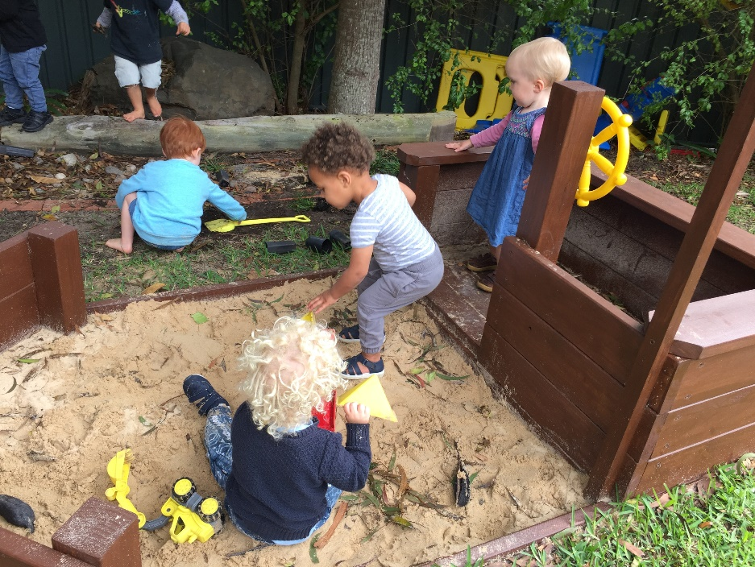

Connecting Meaningfully. Inspiring Hope. Transforming Lives. Through Faith In Jesus.

6 St Alban’s Pl
FORSTER 2428
Office hours - Mon–Thurs Email: info@forsteranglican.com
9am – 12 noon Website: www.forsteranglican.com
Phone: (02) 5543 7683 Fb: Forster Anglican Church Community

Printed Tuesday, 29 January 2019
TRADITIONAL
Date | OT Passage | Epistle | Gospel
6 January ^{Epiphany} | Isaiah 60.1-6 | Ephesians 3.1-12 | Matthew 2.1-12
13 January | Isaiah 43.1-7 | Acts 8.14-17 | Luke 3.15-22
20 January | Isaiah 62.1-5 | 1 Cor 12.1-11 | John 2.1-11
27 January | Neh 8.1-3, 5-6, 8-10 | 1 Cor 12.12-31 | Luke 4.14-21
3 February | Jeremiah 1.4-10 | 1 Cor 13.1-13 | Luke 4.21-30
10 February | Isaiah 6.1-8(9-13) | 1 Cor 15.1-11 | Luke 5.1-11
17 February | Jeremiah 17.5-10 | 1 Cor 15.12-34 | Luke 6.17-26
24 February | Gen 45.3-11, 15 | 1 Cor 15.35-58 | Luke 6.27-38
3 March ^{Transfiguration} | Exodus 34.29-35 | 2 Cor 3.12-4.2 | Luke 9.28-43
10 March ^{Lent 1} | Deut 26.1-11 | Rom 10.4-13 | Luke 4.1-15
17 March ^{Lent 2 AGM} | Gen 15.1-12, 17-18 | Phil 3.17-4.1 | Luke 13.1-9
24 March ^{Lent 3} | Isa 55.1-9 | 1 Cor 10.1-13 | Luke 13.22-35
31 March ^{Lent 4} | Josh 5.2-12 | 1 Cor 5.16-21 | Luke 15.11-32
7 April ^{Lents 5} | Isaiah 43.16-21 | Phil 3.3-14 | John 12.1-8
14 April ^{Palm Sunday} | Isaiah 50.4-9a | Phil 2.5-11 | Luke 19.28-40
19 April ^{Good Friday} | Isaiah 52.13-53.12 | 1 Cor 1.18-31 | John 18.1-19.42
21 April ^{Easter Day} | Isaiah 65.17-25 | 1 Cor 15.19-26 | Luke 24.1-12
28 April ^{Easter 2} | Acts 5.27-32 | Rev 1.4-8 | John 20.19-31
ALL-AGE
Date | Focus Passage | Topic
6 January | Matthew 2.1-12 | Wise Magi Honour Jesus
13 January | Luke 3.15-22 | Why Baptism?
20 January | John 2.1-11 | Wedding Miracle
27 January | Luke 4.14-21 | Prophecy is Fulfilled
3 February | 1 Cor 13.1-13 | What is Love?
10 February | 1 Cor 15.1-11 | Eyewitnesses!
17 February | 1 Cor 15.12-34 | Resurrection!
24 February | 1 Cor 15.35-58 | Spiritual Bodies?
3 March ^{Transfiguration} | Luke 9.28-43 | Jesus Glorified
10 March ^{Lent 1} | Luke 4.1-15 | Jesus Tempted
17 March ^{Lent 2 AGM} | Luke 13.1-9 | Repent
24 March ^{Lent 3} | Luke 13.22-35 | Which Door?
31 March ^{Lent 4} | Luke 15.11-32 | The Prodigal Returns
7 April ^{Lents 5} | John 12.1-8 | Preparing for Burial
14 April ^{Palm Sunday} | Luke 19.28-40 | The humble King
19 April ^{Good Friday} | TBA | Jesus sacrifice
21 April ^{Easter Day} | Luke 24.1-12 | He is Risen!!
28 April ^{Easter 2} | John 20.19-31 | Stop doubting and believe

JOIN A GROWTH GROUP (School term)

KYB … KRAMBACH Tuesdays (1st, 3rd) …1.30pm Peg ……… 6559 1238
FORSTER Tuesdays ……………. 5.30pm Doug ……… 6554 9175
St Paul’s … NABIAC Tuesdays (2nd) ……. 6-7pm Geraldine….…… 6554 1409
St Albans … FORSTER Thursdays …………. 10.30am Rev Helen …. 0427 592 723
St Albans Thursdays …………… 2-3pm Heather ……… 6557 5454
Golden Ponds Fridays ………………. 1-3pm Clive .... 0412 653 061

JOIN US FOR PRAYER

Prayer Time Wednesdays ……….. 8.45am-9:30am St. Alban’s
Prayer Chain Please contact the Parish Office for more info

CONNECT WITH OUR COMMUNITY (School term)

ToddlerTime Mondays ….9.30-11.30am Trish … 0433 952 360
Scripture Forster Fridays ……. 9.30-11.30am Rev Mark … 0425 265 547
Krambach Fridays ……. 9.30 & 10am Dennis … 6559 1815
SIFT Committee Dennis

REGULAR COMMUNITY CONNECTIONS

Bookshop Mon – Fri ……. 9:00am - 12pm St Alban’s
Op Shop Mon – Fri ……. 9:00am - 4pm & Sat - 9-12.30 Head St

Culture and Christ Mon …. 9.30-11.30am Rev Helen … 0427 592 723

Strolling Group Mons 1st & 3rd - 9.30am St Alban’s carpark
Gardening Group Tuesdays - 9am St Alban’s
Rugrats Tuesdays - 10am St Alban’s Hall

Friendship Group 1st Wednesday - 10am St Alban’s
Light Lunch 2nd Wednesday - 11.30am St Alban’s Hall
Pastoral Partners Heather …6555 3651

JOIN OUR REGULAR EVENTS
Tea, Toast & Theology Wednesdays ……. 8:00 - 8:45am St Albans Men’s Dinner 1st Tuesday ……… 6pm (bi-monthly) St Alban’s
Working Bee Mon Mar 4 ………. 8:00-11.30am St Alban’s
Games Afternoon 2nd Sat ………………. 1:00pm – 3:00pm St Alban’s Hall
OUR RETIREMENT VILLAGE SERVICES
ESTIA Forster 1st Wednesday ………. 10.30am Rev Mark
ESTIA Tuncurry 13 March ……………….. 10.30am Pat Sanderson
GLAICA 1st Wednesday ……….. 2:00pm Pat Sanderson
Kularoo 3rd Wednesday ……….. 11:00am Rev Mark
Golden Ponds 27 March ……………….…. 10:00am Rev Mark

HOME VISITING TEAM
Rev Mark Rev James Rev Helen Pat Sanderson

JOIN US FOR WORSHIP AT ST ALBANS
Sundays: 8.30am …………………………………………………. Holy Communion **
10 am ……… All-Age ……….. (Communion on the last Sunday) **
5.30pm …….. (plus nibbles & chat) ……. All-Age + Communion**
Thursdays: 9.30am ………………………………………………… Holy Communion

OUR COUNTRY WORSHIP SERVICES
St. Paul’s: 10am All-Age – 1st Sunday
10am Holy Communion – 3rd Sunday
Dyer’s: 10am All-Age – 2nd Sunday
10am Holy Communion – 4th Sunday

** Sunday 17th March – Join us at St Alban’s for the AGM - 9.30am!

OUR LEADERSHIP TEAM
Senior Minister … Rev Mark Harris Mob: 0425 265 547
(Days of rest – Fri & Sat) Email: revmarkharris@icloud.com
Family Minister … Rev James Brooks Mob: 0411 335 087
(Days of rest – Tues & Sat) Email: jamesknac@gmail.com
Priest in Local Mission … Rev Helen Quinn Mob: 0427 592 723
(Days of rest – Fri & Sat) Email: rqu783662@bigpond.com

Lay Ministry Team
Dennis Ang Phillip Castle Pat Sanderson Clive Davies Caleb Harris

Parish Council Executive
Rector’s Warden – Clive Davies People’s Wardens – Kit Carson & Barry Levick Parish Secretary – Judy Hall Treasurer – Sandra Martin

Parish Councillors
Dennis Ang Suellen Belton Phillip Castle Heather Dwyer
John Sanderson Ray Shephard Safety Delegate – Heather Webster Mission Secretary – Ann Shephard

Parish Council Meetings ……. 2nd Tuesday … 4:00pm-6:00pm St Alban’s Hall

